About Page

Project Overview

The Haven builds a community of dreamers where anyone, no matter their background, can imagine their own dream home. It starts with a digital space that collects and shares these stories, creating a place where people can see themselves, connect through their experiences, and find inspiration in the way others define home.

The Haven is a passion project conceived and executed by Communication Arts students from De La Salle University: Anne Nicole Zambrano and Kirsten Jewel Garcia.


Anne Nicole Zambrano

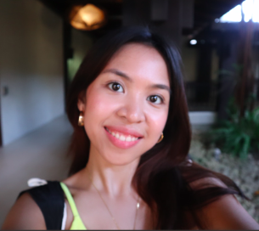
Kirsten Jewel Garcia

This project is a journalistic investigation into the emotional, financial, and psychological landscape of modern Filipino living, committed to blending academic theory with authentic, raw narrative nonfiction. The creators believe that by documenting the dream, we help make the future possible.

Date of publication, November 2025. Conceptualized in June 2025.

Mission

To document and narrativize the emotional architecture of the Filipino home, moving beyond physical structure to explore how memory, aspiration, and everyday life shape our sense of belonging. We aim to leverage immersive storytelling to bridge the gap between the design of spaces and lived experience, making personal struggles for autonomy and control universally relatable.

Vision

To be the digital sanctuary where Filipinos redefine the meaning of 'home', a space that prioritizes peace, self-definition, and emotional stability over financial metrics. Our vision is to create an online community built on shared vulnerability that empowers every individual to see their living space not just as a structure but as a blueprint for their desired future self.

